<!DOCTYPE html>

<html lang="en">

<head>

    <meta charset="UTF-8">

    <meta name="viewport" content="width=device-width, initial-scale=1.0">

    <title>Document</title>

</head>

<body>

    <script>

        document.write("wao")

        var a=1;

        var b="two";

        var c=true;

        var d="thre";

        alert(b+d);

    </script>

</body>

</html>

For external add

We created file .js

In js document.write(“wao”)

Then in main file add

<script src=file.js>

</script>

**If we don’t use var so its become global variable**

<script>

    var b=3         //global

    function a(){

    document.write(b);

    d=2  //local        if we remove var before d its become global varibale

    }

    a()

    document.write(b);

    document.write(d);

array

  <script>

        var a=["nice","wise","rise","dice"]

        document.write(a);

        document.write("<br>");

        var b=[["nice","wise"],["rise","dice"]]

        document.write(b[1][0]);

    </script>

/* */

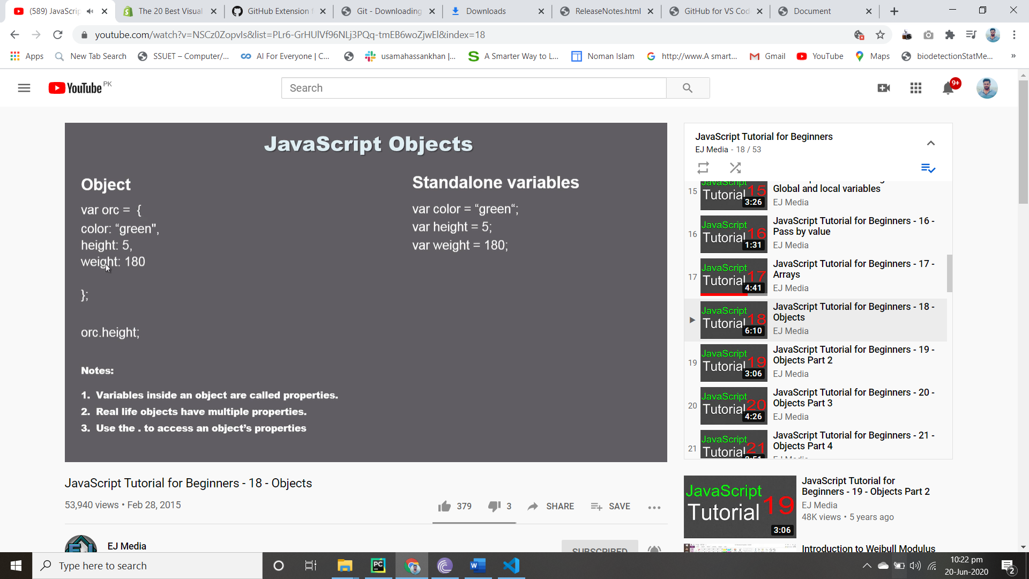

Fuction in Objection

 <script>

    var obj={

        color:1,

        size:3,

        name:"wap",

        wife:"rawao",

        yell:function(){

            document.write("its funcction f objct ");

        }

    }

    document.write(obj.color);

    obj.yell();

</script>

Delete and initialize again]

<script>

    var obj={

        color:1,

        size:3,

        name:"wap",

        wife:"rawao",

        yell:function(){

            document.write("its funcction f objct ");

        }

    }

    document.write(obj.color);

    obj.yell();

   document.write( obj.face="moo");

    delete obj.face;

    document.write( obj.face);

    delete obj.size

    document.write(obj.size);

</script>

Dom

<body>

    <p id="wao"> this is good </p>

    <button type="submit" ,onclick="a()">click kar</button>

    <script>

function a(){

    document.getElementById("wao").style.color="blue";

}

</script>

Dom by tagname

<body>

    <p class="po"> this is p 1</p>

    <p class="po"> this is p 2</p>

    <p class="po"> this is p 3</p>

    <p class="po"> this is p 4</p>

    <button onclick="fl()"> click</button>

    <button onclick="cl()"> click class</button>

    <script>

function fl(){

    var paragraph =document.getElementsByTagName("p");

    var paragraphtext=paragraph[0].style.fontStyle="italic";

    var paragraphtext=paragraph[1].style.color="pink";

    var paragraphtext=paragraph[2].style.color="red";

    var paragraphtext=paragraph[3].style.color="orange";

}

Classname dom

function cl(){

    var paragraph =document.getElementsByClassName("po");

    var paragraphtext=paragraph[0].style.fontStyle="italic";

    var paragraphtext=paragraph[1].style.color="pink";

    var paragraphtext=paragraph[2].style.color="red";

    var paragraphtext=paragraph[3].style.color="orange";

}

    </script>

Inner html use to change or edit text of html

<body>

    <p class="po"> this is p 1</p>

    <p class="po"> this is p 2</p>

    <p class="po"> this is p 3</p>

    <p class="po"> this is p 4</p>

    <button onclick="fl()"> click</button>

    <script>

function fl(){

    var paragraph =document.getElementsByTagName("p");

    var paragraphtext=paragraph[0].innerHTML="this is edited p1";

    var paragraphtext=paragraph[1].innerHTML="this is edited p2";

    var paragraphtext=paragraph[2].innerHTML="this is edited p3";

    var paragraphtext=paragraph[3].innerHTML="this is edited p4";

}

</script>

</body>

Retrive value and add

<body>

    <p class="po"> this is p 0</p>

    <p class="po"> this is p 1</p>

    <p class="po"> this is p 2</p>

    <p class="po"> this is p 3</p>

    <p class="po"> this is p 4</p>

    <p class="po"> this is p 5</p>

    <p class="po"> this is p 6</p>

    <p class="po"> this is p 7</p>

    <button onclick="fl()"> click</button>

    <script>

function fl(){

    var paragraph =document.getElementsByTagName("p");

    var paragraphtext=paragraph[0].innerHTML="this is edited p1";

    var paragraphtext=paragraph[1].innerHTML="this is edited p2";

    var paragraphtext=paragraph[2].innerHTML="this is edited p3";

    var paragraphtext=paragraph[3].innerHTML="this is edited p4";

    var paragraphtext1=paragraph[5].innerHTML;

    var paragraphtext2=paragraph[6].innerHTML;

    paragraph[7].innerHTML=paragraphtext1+paragraphtext2;

}

</script>